MACH4METAL

metalworking machinery
Transito 21
6909 DA BABBERICH Netherlands
Tel. +31 (0)316-247123
Fax: +31 (0)316-247956

Bank No : 66.52.13.883
IBAN : NL33 INGB 0665 2138 83
BIC : INGBNL2A

FACCIN Dishing machine BF 42 x 8000 mm
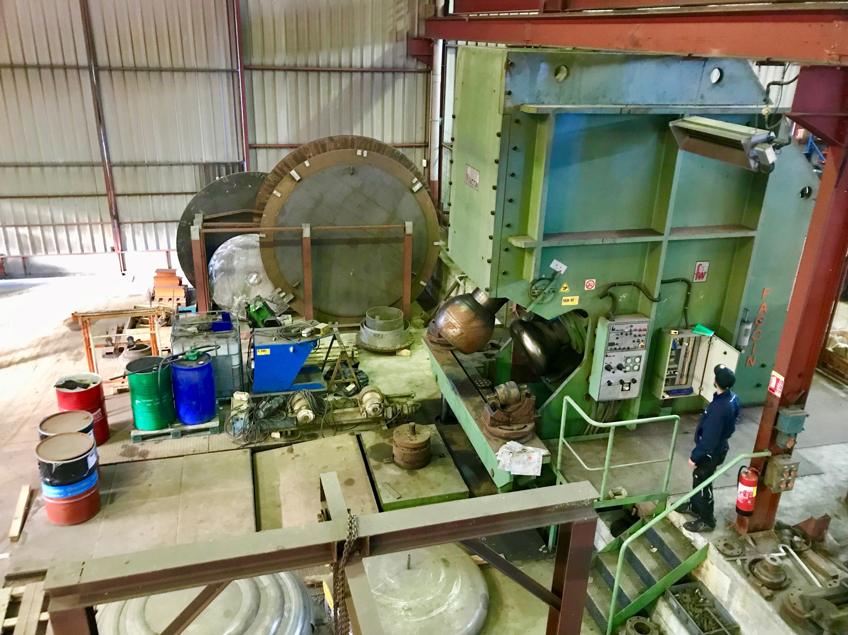
- Make : FACCIN Italia
- Type : BF 42 / 8000
- Serial : 1751
- YOP : 1999

- Max. work piece : 8.000
- Max. bending : 7.600
- Max. thickness steel : 42
- Max. thickness stainless : 30

- Max. product height : 1.800
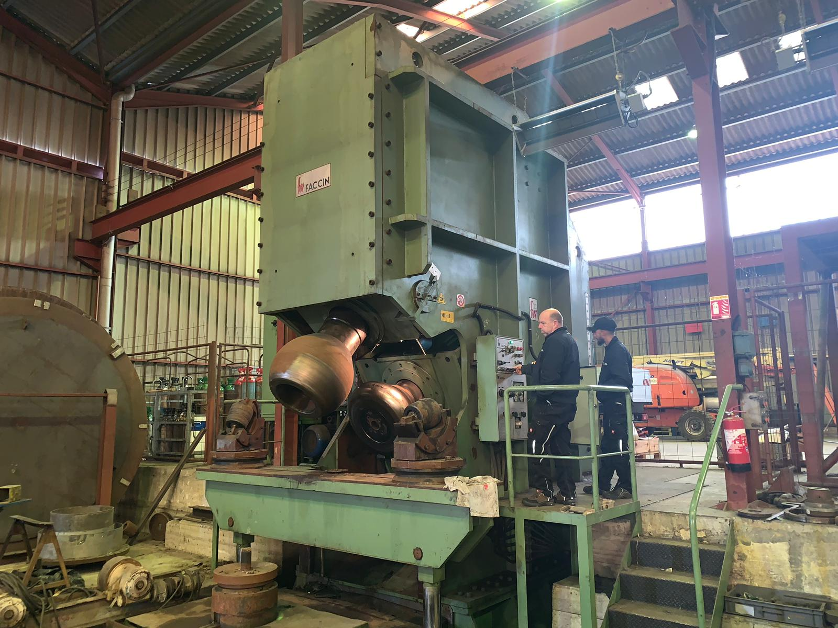
- Max. straal : 800
- Passing height : 2.000

- Radius rolls : 100/150/200/300
400/500/600/700
- Working speed 1-2-3: …

- Dimensions
- Length : 10.000
- Width : 3.400
- Height : 7.605
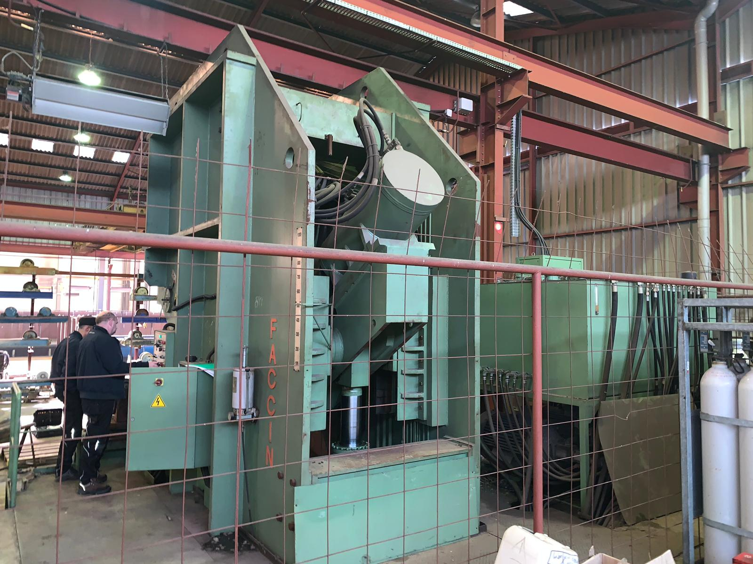
- Weight : 118.000
- Power : 130 kw

Solution for production HEADS Manufacturing
the hydraulic press with to 800 ton is versatile
to be used for dishing, straightening and
swaging operations, in combination with
automatic manipulator, a plate handling system
to automation the manufacturing process,
finished with the BF automatic flanging
machine “ with centre hole “design
dished heads.

Please Note: The above information has been obtained to the best of our ability and belief from, and from the manufacturers where possible. It is given in good faith, but its accuracy can not be guaranteed. Accordingly, it will not form a representation or constitute contractual terms. We advise you to check any vital details!

